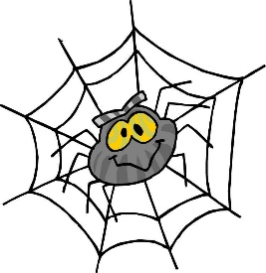

Hello and welcome to our video conference! My name is Valerie Marsh and I am a classroom teacher who accidentally became a storyteller and then an author. Here is my story: I was assigned lunch duty during my prep period! Rather than constantly asking the students to keep the noise level down, I started telling stories using sign language, drawing on paper or cutting out a paper object. It worked! Not only were the students quiet enough to listen, they wanted to draw and tell their own stories! Then I discovered that using these easy methods was also a great way to encourage the ‘reluctant writers’ in my own classroom. I knew that other teachers also had reluctant writers in their classrooms, so I compiled my ideas into how-to resource books. I have written 13 books on these fun, easy methods of storytelling and writing, including Paper-Cutting Stories from A to Z, Puppet Tales, Top Dot Tales, Trickster Tales, True Tales of Heroes and Heroines and others. I sincerely hope that these quirky story-telling and writing methods will inspire you and your students to write and tell your own stories.
If we are doing an Action Science program with your class, you will also get to meet Miss Liz Science Wiz! Liz Boger is an experienced preschool science teacher who loves encouraging young children to get physically involved with science! Because that is one of the best ways for children to learn right?! That’s why we are going to be doing some crazy fun activities during our science video conference!
My goal is to present the best possible program to your students! Please help by emailing a bit about your students, what your class is studying and how I can personalize this program for your students. Email either of us soon!
valeriemarsh@juno.com misslizthesciencewiz@gmail.com

